1. Creating and Renaming Files/Directories

Create a directory named test_dir using mkdir.

Inside test_dir, create an empty file called example.txt using touch.

Rename example.txt to renamed_example.txt using mv



* mkdir test_dir → Creates a directory named test_dir.
* touch test_dir/example.txt → Creates an empty file example.txt inside test_dir.
* mv test_dir/example.txt test_dir/renamed_example.txt → Renames example.txt to renamed_example.txt.

2. Viewing File Contents

Use cat to display the contents of /etc/passwd.

Display only the first 5 lines of /etc/passwd using head.

Display only the last 5 lines of /etc/passwd using tail.

cat /etc/passwd → Displays the full content of /etc/passwd.

head -n 5 /etc/passwd → Shows the first 5 lines of /etc/passwd.

tail -n 5 /etc/passwd → Shows the last 5 lines of /etc/passwd.

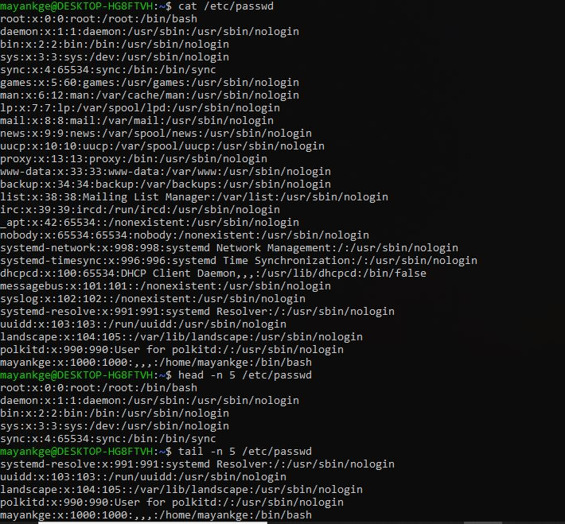

3.Searching for Patterns

Use grep to find all lines containing the word "root" in /etc/passwd.



grep "root" /etc/passwd → Finds and displays all lines containing "root" in /etc/passwd.

4. Zipping and Unzipping

Compress the test_dir directory into a file named test_dir.zip using zip.

Unzip test_dir.zip into a new directory named unzipped_dir.

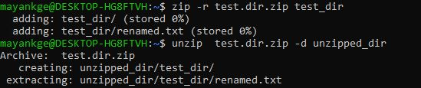

zip -r test_dir.zip test_dir → Compresses the test_dir directory into test_dir.zip.

unzip test_dir.zip -d unzipped_dir → Extracts test_dir.zip into unzipped_dir.

5. Downloading Files

Use wget to download a file from a URL (e.g., <https://example.com/sample.txt>).

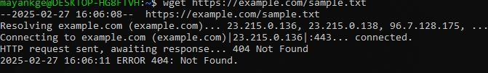

zip -r test_dir.zip test_dir → Compresses the test_dir directory into test_dir.zip.

unzip test_dir.zip -d unzipped_dir → Extracts test_dir.zip into unzipped_dir.

6. Changing Permissions

Create a file named secure.txt and change its permissions to read-only for everyone using chmod.

touch secure.txt → Creates an empty file named secure.txt.

chmod 444 secure.txt → Sets secure.txt as read-only for all users.



7. Working with Environment Variables

Use export to set a new environment variable called MY_VAR with the value "Hello, Linux!".

Use echo to display the value of MY_VAR.

export MY_VAR="Hello, Linux!" → Sets an environment variable MY_VAR with value "Hello, Linux!".

echo $MY_VAR → Displays the value of MY_VAR.



**Submission Guidelines -:** Attach Screenshots or command along with explanation and submit in doc(google doc or microsoft doc) format